2014 Bruxelles – Strasbourg – Bruxelles: From Lemons to Lemonade
By E.W. (Wim) Kok
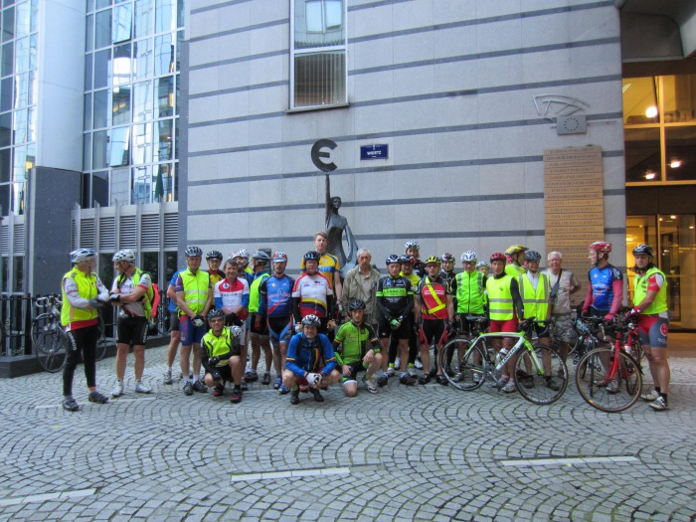
Riders at the European Parliament Brussels

Introduction
After struggling with the longer brevets, I was back in 2014. The challenges had been mental in that incorrect pacing and nutrition during 600+ brevets resulted in a few abandons. This year I did the early 200 on Vancouver Island, another one in Edmonton, and a challenging windy 300 in the Peace. On the Peace 400 I came no further than 251 km when deteriorating weather and exhaustion got the better of me and I threw in the towel. Within a week a successful rebound at the Central Alberta 400, followed by the challenging Banff-Jasper-Banff 600 with the Alberta Randonneurs in mid-June. The latter went well, including the extensive climbing. Now it was time to decide which 1200 km to ride. Two considerations (a) a planned trip to the Netherlands and (b) the amount of available recovery needed after the 600. Between the German Grosse Bayern (1267), the Scottish Highlands (1300) and BSB, the choice came down to Brussels-Strasbourg-Brussels, an event organized by Aurore-Cyclo Saint Gilles, or more specifically Andre van Eeckhout. Andre is a passionate and veteran randonneur with LEL, PBP and other 1200s, including the 2008 Paris-Beijing ride under his belt. Impressive credentials.
The Belgian-French super brevet ran in four stages with overnight stays in Verdun (2x) and Strasbourg, with organized breakfasts before the crack of dawn. Daily distances would be 327km – 288km – 293km – 290km; daily elevation gain 2464m -1894m-2115m-1828m for a total of 8,301m or 27,670 feet. Very nicely spaced.
(http://aurore-cyclo-rm1200km-bruxelles-strasbourg-bruxelles.skynetblogs.be/)
When I saw the detailed route sheet with lots of directions, I surrendered and purchased a GPS, the GarminMAP62s and CityNavigator 2014 map for Europe to assist with navigation. Route sheet and hard cover map would still be my back-up, just in case. The bicycle also got a good work-over with new cassette, chain and chain rings. Test rides revealed no issues. I was ready to go.

The Day before………..
Travelling by train from my Dutch stomping grounds to Brussels was easy. Cycling from Bruxelles Midi to the hotel in Anderlecht should have been easy as well, but it turned out anything but. I did have the choice of the Metro, but declined. Instead I opted to cycle that stretch. A serious mistake it appeared. Unfortunately it poured when I wanted to leave the station: buckets, cats and dogs, the proverbial stuff. It was wet in the City of Manneken Pis.
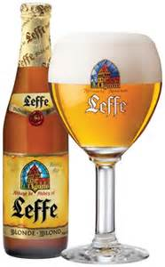
So I waited until it improved and then cycled slowly on account of slippery cobbles and puddles. Vehicle traffic did not give a damn about cyclists and happily splashed any two-wheeler they passed. I pressed onward and found my way. Things were not quite clear re. accessing the hotel along a major artery, so I ended up on a narrow path. Wrong route. As I backtracked. my rear tire went limp. What I did not realize then was that this was the beginning of a very tyre-some affaire. Anyway, the first flat. Not very good, but alas! I had spare tubes, I had a pump and I knew what to do, although my practice was a bit scant on account of just about no flats in quite a few years. So far this year with more than 3,500 km on the road, only one flat. Tires were in good shape. No evidence of sharp objects inside the tire, so replacing the tube would be a routine and effortless affair. Time to inflate it, which went well until the valve stem snapped off, just above the opening in the rim. That was the end of that spare tube. With an “I’d be jiggered” exclamation under my breath, I began to think that this disconcerting. Next, try another spare and new tyre, just to be on the safe side. Pumped it up, hard that is. Reloaded everything - I thought - and resumed the ride. It was not long before I had another one, my third flat. That was indeed not looking very good. Very bad actually. Thought about patching the two leaky spares, but then realized that I had lost my pump somewhere. The obvious verdict: “Wim, you are “SOL”. Solution: (1) walk to the hotel and (2) come up with solutions there. Close to the hotel I noted a large Decathalon store, which unfortunately had closed by the time I got there; it would not open 9 am next day, too late. No good. After arriving at the hotel I contacted the organizer and explained my dilemma. He graciously assured me a spare pump and some inner tubes. Things began to look up again! To quench my thirst, I made time for a quick ‘Leffe’. After all when in Belgium, do as the Belgians do. Also needed some solid food and took care of that. After that it was down and out for an early rise and start. What a day it was. Little did I know what would be in store.

Day 1: Brussels (Anderlecht) to Verdun (FR): 330 km (for me 75 km to Ham sur Sambre plus another 30 km to make it to Namur)
Breakfast was light consisting of coffee or tea and waffles and small cakes, enough to get the body going. Got everything for the bicycle, courtesy of Andre and a few riders whose names I unfortunately did not get. Much appreciated, gentlemen. Just before 6:00 am we gathered outside the hotel Erasme, where Andre and his brother Yvon welcomed 28 riders, provided a few instructions, and wished us bonne route. Off we were!! We cycled to the European Parliament for a group photo.
The brevet then started in earnest rolling over varying road surfaces, ranging from pavement to cobbles, gravel, etc. Temperatures were fine as was the pace. No-one suffered from adrenaline rushes or need-to-race urges. The topography was slightly undulating. All in all it was a great morning to be cycling. We were more than two hours into the ride when my rear tire went flat after a rough cobblestone descent (again). Needless to say that I was less than impressed. This time the leak was a tiny hole near the valve stem. Obviously that called for a new tube, which I installed without any problems. I resumed the ride full of optimism, knowing that the organizers – as promised -- would meet me at some point with spare tubes. After all I had none left. The region of Belgium we were cycling in was hilly, sparsely populated and bicycle stores were rare. I was about to discover that later. Near Ottignies the route followed a bicycle pathway. The path had a lot of debris left by recent storms. In Mousty another flat, this time a deep glass cut. Put in a tyre boot and tried to patch the tube. That did not work. Now what? Instead of waiting I started walking along the route with every expectation that at some point the organizers and I would meet up and all would be well. That was my optimistic way of looking at it. Unfortunately it did not happen. Obviously we missed each other. Meanwhile I walked, walked and walked some more. The weather was fine, I felt good and knew that I had still enough time in the bank to make it to the first control in time. I enjoyed the landscape, snapped pictures.

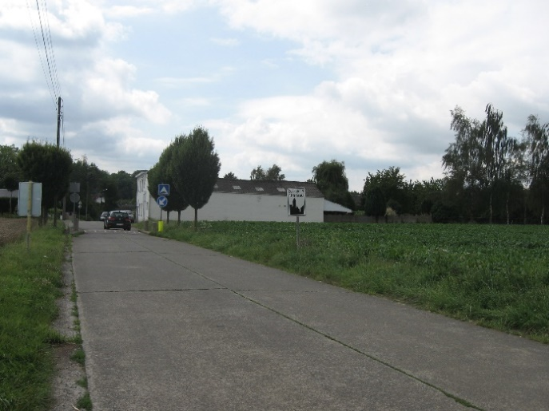 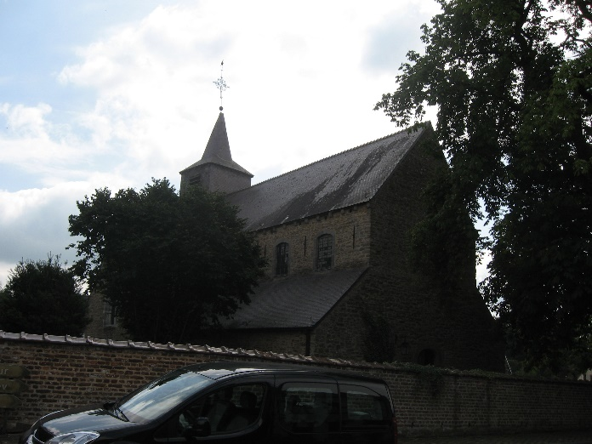Corroy-le-Chateau

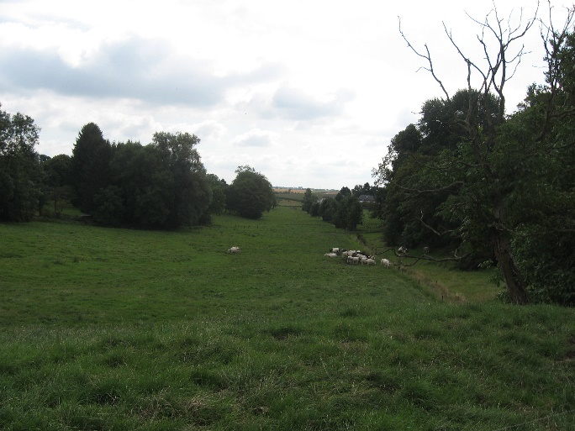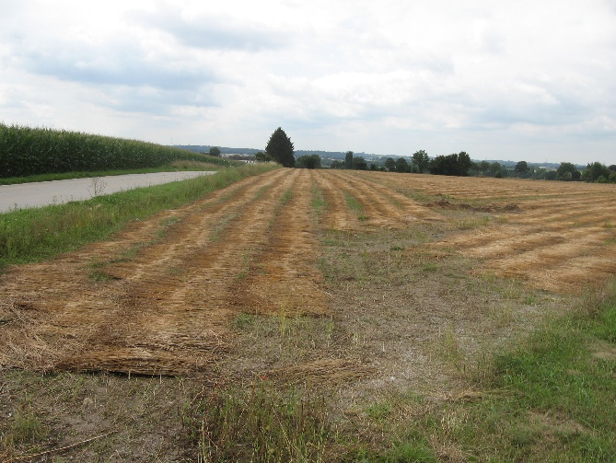
Valley with livestock. Field with flax, cut in swaths.
Well some 32.5 km later I finally found a bicycle store in Ham sur Sambre. Dumont Fils fixed the problem. Thanks gentlemen. Armed with a new tyre and tube (and to be on the safe side 3 spares!!), I set out and took stock. By now the first control at Maredsous (Km 102) was still 23 km away. It would have been closed by now. Continuing meant that I’d arrive there some two-and-a-half hours late. Technically I was out of the event. I most likely would have made the following control, Charleville-Mezieres (Km 210) by closing time, close to 10:00 pm and then I had still another 115 km to go to Verdun (Km 327). I weighed my options. Time to start making lemonade out of my (tyre) lemons, so I decided to cycle to Namur along the Sambre river. I did have another flat. Oh well. At least changing tires was now one of my fortes. Once in Namur, I looked for a train to Verdun to catch-up with the group. Since none were available, I booked one for Strasbourg for the next day, so that I could rejoin the riders there. Then found a hotel, had a good meal, enjoyed another Belgian brew and a good sleep.

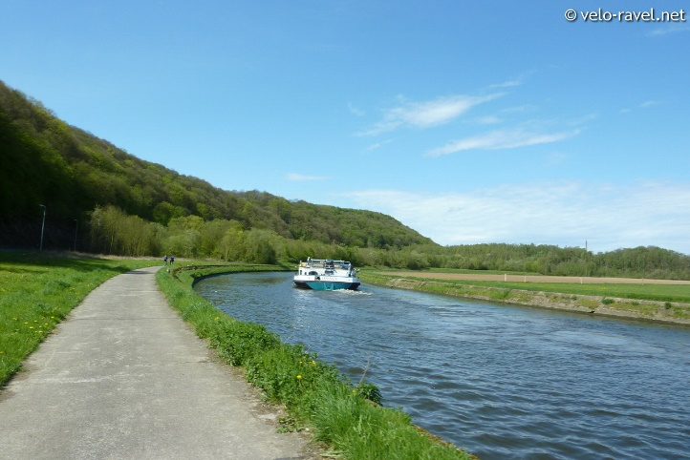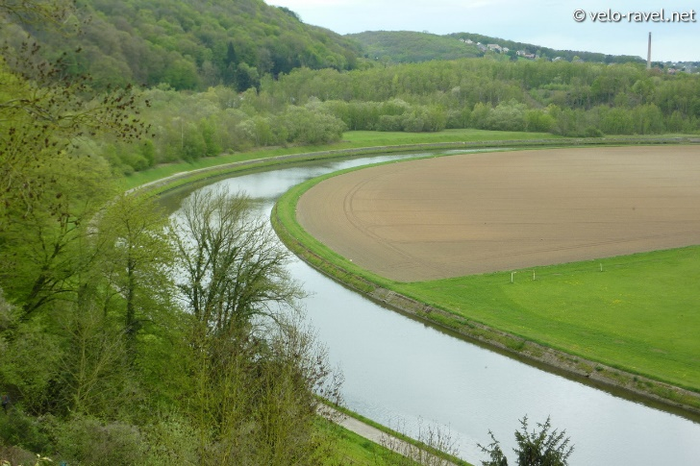
Bike path along the Sambre
(Source: http://i716.photobucket.com/albums/ww162/lbs007/_2012/2012-04-30%20RAVeL%201%20Centre%20Namur%20-%20Ham-sur-Sambre/2012-04-30RAVeL1CentreNamur-Ham-sur-Sambre051.jpg)

Day 2: Namur – Strasbourg (by train)
The train trip from Namur via Luxembourg, Metz and Nancy to Strasbourg was comfortable and enjoyable. I arrived early afternoon, navigated my way to Schiltigheim, one of Strasbourg’s suburbs. This brought back good memories as we (my wife and I) spent our holidays in the Alsace last summer (2013). We did a fabulous 7-day B&B bicycle tour along the wine route in the region and added another 4 days of exploring every nook and cranny of Strasbourg. We had done a similar one, a few years earlier, when we cycled from Passau, Germany along the Danube to Vienna, Austria. What a great way to explore the region.
Since the riders would not arrive at the Strasbourg control until 8 pm at the earliest, I explored a bit more of Strasbourg and cycled a section of Day 3’s route. Picked up a few groceries for the next day, and enjoyed another good meal and a brew. When the riders arrived at the hotel, we were assigned rooms, took showers, chatted about the day’s events and turned off the lights for a good night’s rest.
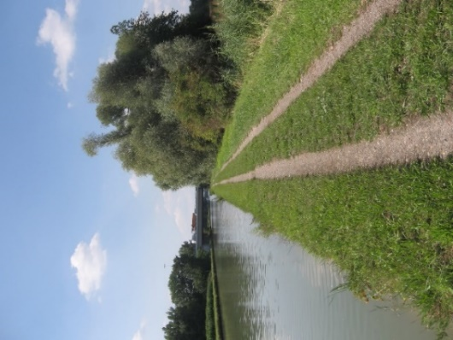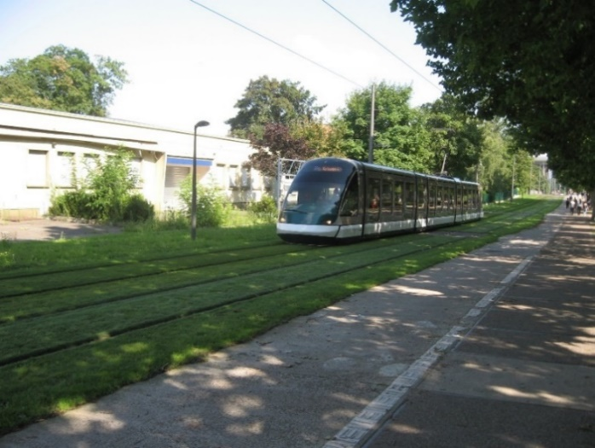
Pathway Marne-Rhine Canal Public transportation and bike path Strasbourg (not the official route)

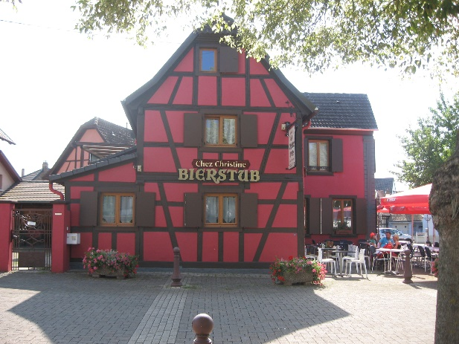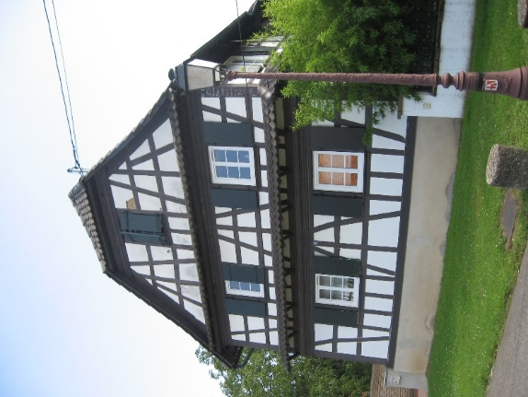
Alsatian “Fachwerk” in Hoenheim, just north of Strasbourg

Day 3 Strasbourg- Verdun (293 km)
Breakfast was set for 4:30 am. Most riders sauntered in, but as the calories were liberated, spirits rose. Today’s stage would first go to the European Parliament for a group picture, then proceed to Verdun. There was little enthusiasm for the European Parliament as an institution. This was evident during breakfast. The (g)rumblings had nothing to do with this brevet, but more with revelations about parliamentarians claiming funds and then not showing up for work: a culture of entitlement. Disgusting behaviour, which created deep popular resentment. Sounds familiar? After the breakfast discussion on this topic, everyone’s focus shifted to today’s ride. I was certainly eager to get going; I was pumped as much as the tyres on my bicycle: 110 psi+, if you get my

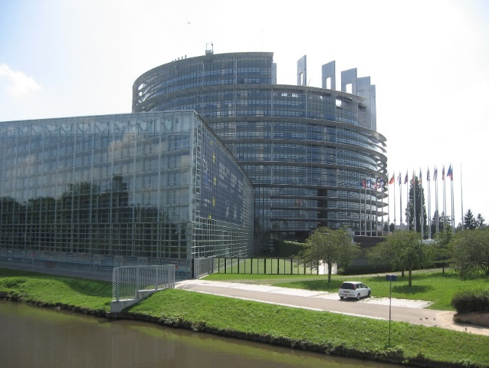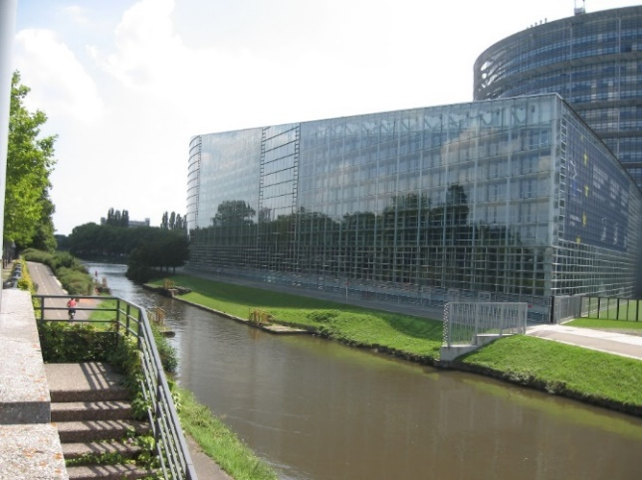
Strasbourg: European Parliament with bike path along Marne-Rhine Canal
drift. Packed the bicycle, delivered the drop bag and cycled to the EP, only 10 minutes away. There was one other rider, who claimed that his nationality belonged to “the country with highest hop contents in its beer.” Many would drink to that, I’d say. We took a look at remarkable architecture of the building and then descended the ramp to get on the bicycle path along the Marne – Rhine Canal. Away from traffic. No wind, great temperatures. I picked up the pace, and moved along, enjoying the landscape, the water and the morning mist. No idea how I fared, but at a pace at 25-28 kmh; it felt effortless. The bicycle behaved very much as it should. Quite a few runners and cyclists were out for their morning exercise. Stopped for a couple of minutes to chat with one of them. He was both impressed and curious about all these fast moving cyclists. Ha, an opportunity to explain randonneuring, which needless to say I shamelessly exploited.
Along the canal several blue herons in flight were looking for food; a lonely stork – Alsace’s folk symbol – stood one-legged and obviously deep in thought, pondering what? Planning another delivery, or recovering from the previous one? Quite a few cats were out, looking for their morning prey, ingredients for -- you guessed it – their cat’s breakfast. Well, those thoughts bubble up when one cycles solo for hours. After a few hours I reached Saverne (Km 55), a beautiful city with an impressive ‘chateau’ along the canal.
The ride sofar had gone along the canal and would go for quite a bit more. Very peaceful and inspiring. Just past the castle the valley narrowed, the bicycle path became hemmed in between the canal and a rock wall. Or in other words I cycled between a wet and a hard place. Flowers bloomed, their aromatic scents filled the air. I sucked it deep into my lungs. It could not get any better. Caught up to a French couple

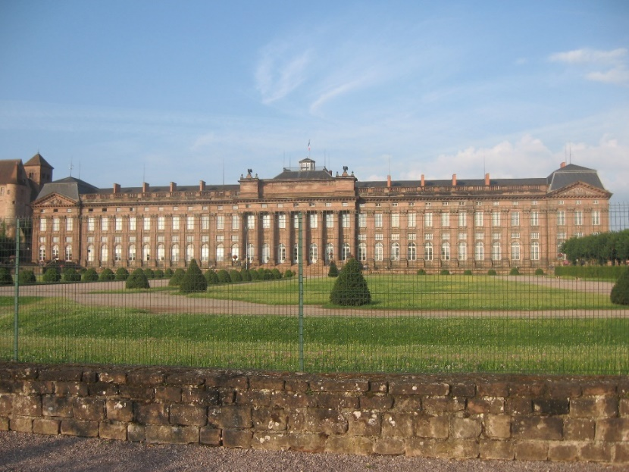

Saverne: Château des Rohan, former residence of the bishops of Strasbourg, rebuilt by Cardinal de Rohan in 1779

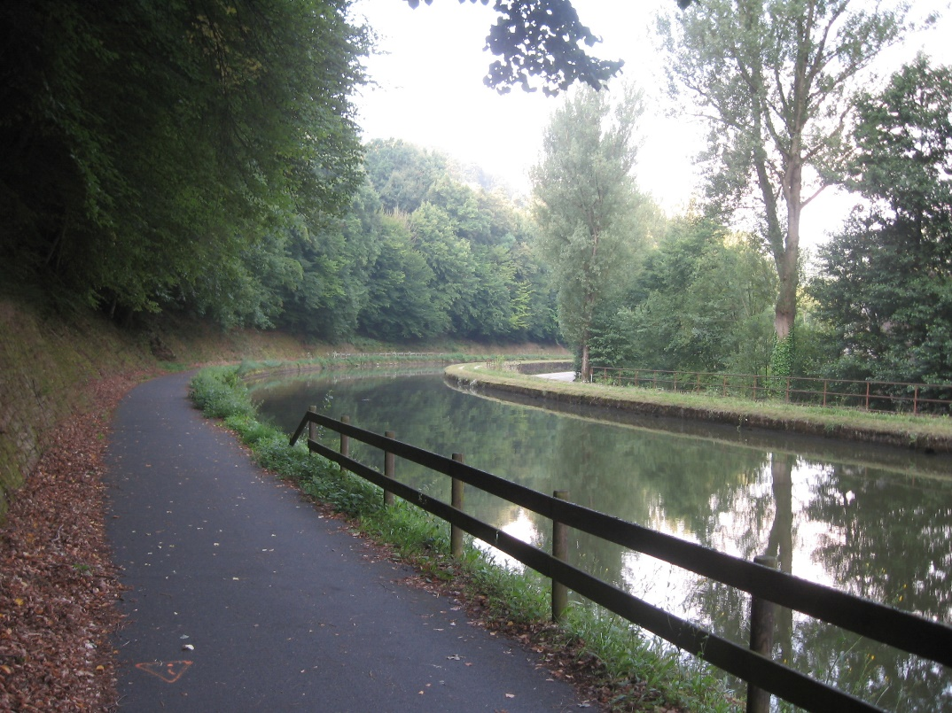
The route along the Marne-Rhine canal, just west of Saverne, France
who were riding the brevet on mountain bikes. We cycled together as we crossed the Vosges mountains. Wonderful environment. Moved through one small attractive village after another. There was some climbing, some descending nothing of the ordinary as far as effort is concerned. Beautiful views. Lutzelbourg, Arzviller, Guntzviller and then in Trois-Fontaines 8.6 km along the Green Route of the Vallee de la Bievre, a great course away from the highway. A few route hesitations past Hesse and Lorquin, but my GPS kept me on the straight and narrow, thus taking the guesswork out of navigation. The countryside had become distinctly agricultural, the terrain continuously rolling, while the temperatures rose. I kept my fluid levels topped up and frequently ate nectarines.
It was not long before we arrived at Luneville (Km135), the first control of the day. We sat down for a leisurely lunch, rested and chatted. After a while, restlessness set in – after all no rest for the wicked – so we resumed our ride; there were still another 158 km to cover on this hot afternoon. The route went – uneventful I might add - via Bayon to Tantonville. Not quite remembering where it was, but as my co-rider Johan and I sailed through a small community, we heard voices calling us off the road for refreshments, courtesy of Andre and his brother Yvon.
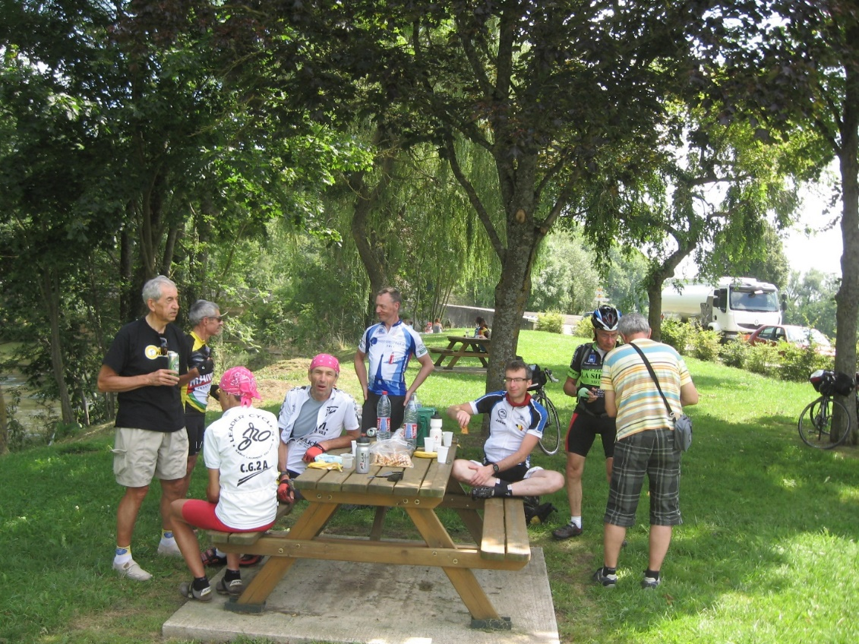

Stop with refreshments organized by Andre (far left) and Yvon (far right)

We took full advantage of the snacks and liquids. Not too long a break as there was still a bit to cover. Another break in Commercy. With still more than 40 km to go I noted that my water bottles were getting critically low. It prompted me to stop and buy water -- just before the stores closed. Good thing, too, because I was thirsty and still had a bit to go. Pace was almost 30kph as I cruised along the west bank of the Meuse from St. Mihiel toward Verdun.
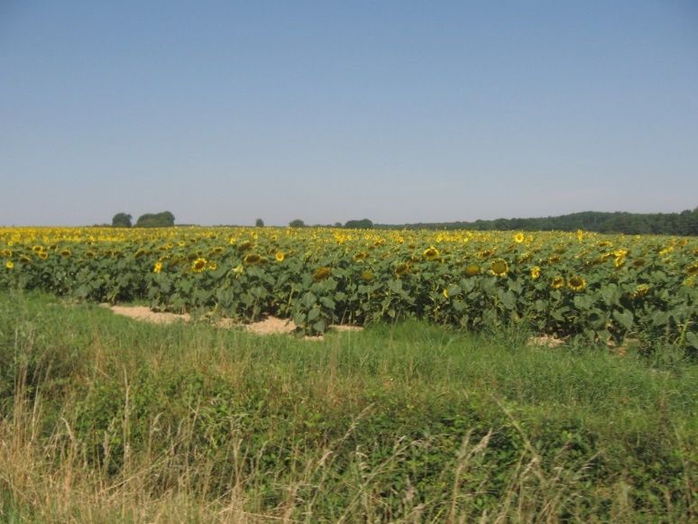
Familiar French landscape: sunflowers – ‘les tournesols’

Passing vehicles in Ancement and Dugny-sur-Meuse were enthusiastically honking their car horns I did not quite know what to make of that, but waved back with a big smile on my face. Thank you for your support. Turned off the main road, crossed the Meuse, climbed a steep hill, then meandered a bit through Verdun, rode along the Quai de la Republique with a panoramic view of the river and the city. Once more across the bridge, and there it was Hotel de Colombes, our destination for the night; arrived just before 9 o’clock.
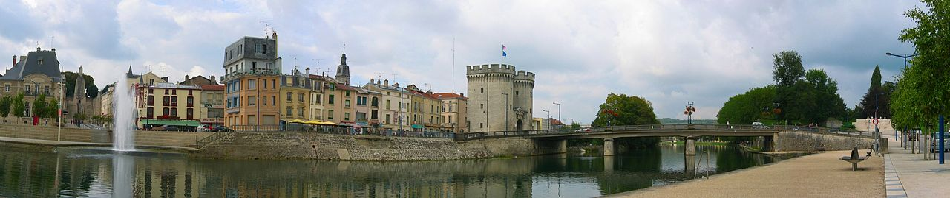
Panoramic view of Verdun along the Meuse.
Source: http://en.wikipedia.org/wiki/Verdun#mediaviewer/File:Verdun_pan_photo_2004.jpg
First things first: a shower, then a quick message home that all was well. After that, time to down a small pizza and cool beer. Back at the hotel, everything was packed and readied for the next day, so that I could leave at moment’s notice.
Verdun, a small city on the Meuse. Verdun, a city where many soldiers, many times the population of Verdun, lost their lives in a protracted battle between French and German armies in WWI. Incomprehensible, grim statistics. What can one say other than citing the words of a French lieutenant at Verdun who wrote in his diary on 23 May 1916:
“Humanity is mad. It must be mad to do what it is doing. What a massacre! What scenes of horror and carnage! I cannot find words to translate my impressions. Hell cannot be so terrible. Men are mad!” Horne, A. (1962). The Price of Glory. London: Macmillan.
Referenced in “The Sleepwalkers – How Europe Went to War in 1914” written by Christopher Clark. One cannot help but ponder these aspects of humankind, as one cycles through this sober and peaceable landscape. It so belies the historic reality buried here.
Day 4: Verdun - Anderlecht (295 km)
Alarm sounded at 4:30 am. Time to get up again and on with it. First breakfast as a group -- more or less -- as a few riders were early out of the gate. Most ate, telling stories and exchanging friendly banter. The mood was upbeat and cheerful. After all it was Day 4, the final day of the brevet. By 5:30 Johan and I packed the bicycles and shortly thereafter we were on our way, leaving Verdun quietly behind us. The morning temperature was on the chilly side; ground fog drifting over low lying areas. We got into the groove and effortless moved along the Meuse valley. Few villages in the area with a few undulations. The sun rose, casting log shadows at first.
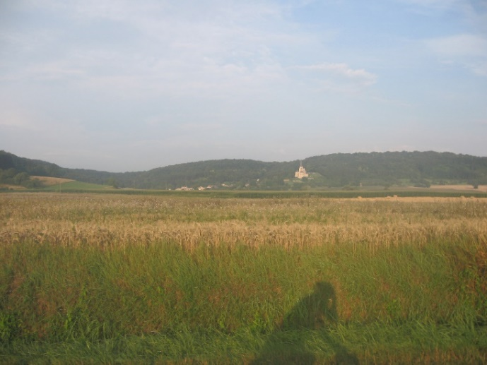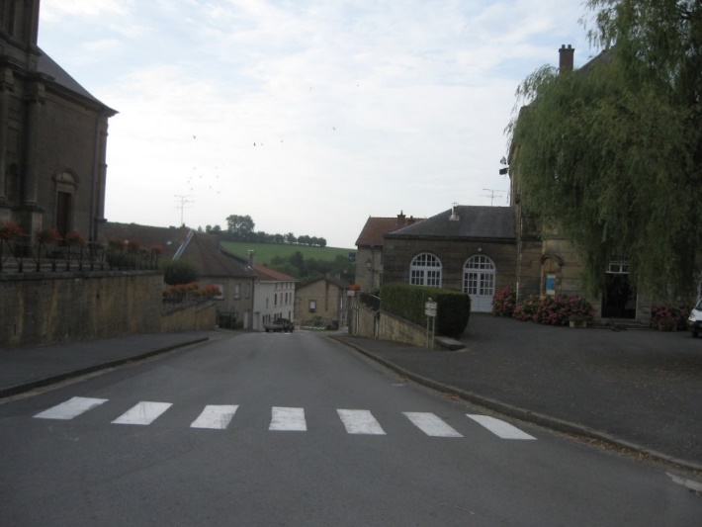
The shadow rider (Meuse valley) Beaumont’s ascent (looking downhill)
Alberta randonneurs familiar with the Camrose 200 know all about Beaumont (AB) where on the return section of that brevet a steep ascent adds a bit of a challenge and at the crest a magnificent church. Guess what, as we approached Beaumont (FR) we also faced a steep ascent with at the crest an impressive church. Geography did repeat itself (in Albert that is). At the town square Andre and Yvon set up a refreshment stop. They recounted how an earlier group of riders had sprinted uphill as if it was the finish of a mountain stage in the Tour de France. We continued the Meuse valley until Charlesville- Mezieres. If the ride had been easy going up to now, things changed after we left the city. First we had to conquer a substantial ascent out of the valley, then a threatening sky. In the end both proved less daunting- the wisdom of hindsight at the top of the climb. There were a few more challenging climbs, mean little ones; they however added spectacular scenery to the ride. It was all worth it. Near Regniowez we
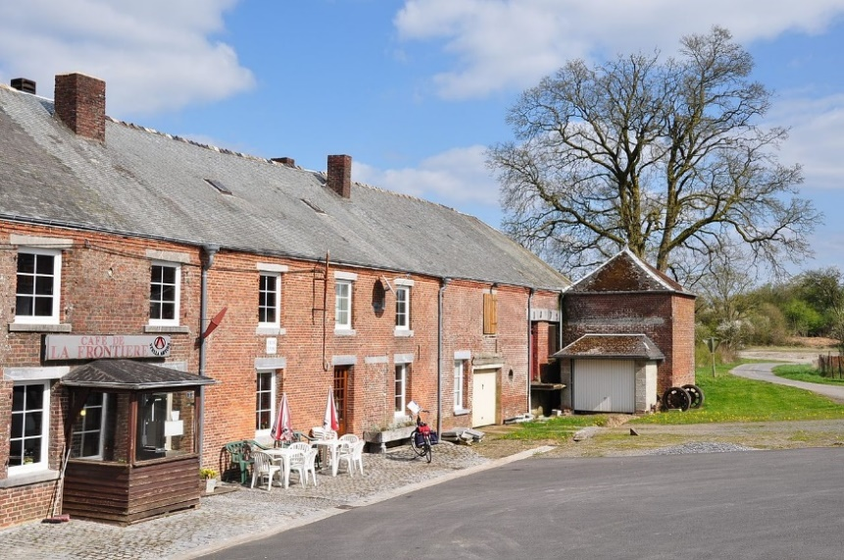
Regniowez: Café de la Frontiere
Source:http://en.wikipedia.org/wiki/Regniowez#mediaviewer/File:France,_Ardennes,_Regniowez_(1).JPG

crossed the French- Belgian border. The former customs building had this human size puppet, resembling a customs officer. Very real, but of course a mockery as the EU made all border controls redundant. We laughed about it.
On our way to Chimay we were entered the source region of the river Oise. Chimay is also the location of the Sourmont Abbey, where Trappist monks brew their famous beers. Here we sat down with for a solid pasta meal and one of those famous beers. Very satisfying, refreshing and relaxing. What else could one add? The reality dawned as we had a few hours left before the brevet was over. So we resumed to cover the remaining 130 km. Soon after Chimay we turned onto an abandoned railway r/w, now paved for cyclists, hikers and other travellers. It took us away from traffic and led us for the next 40+ km through forest, field and small towns. Amazing as the railway grade was slight and our pace was steady. We did have to slow down to pass a drum band which was following their marching orders. To keep me on edge I had another flat tire, this time the result of hitting a sharp rock. Contrary to expected and standard practice it did not shoot away. Just a short intermezzo and our show was on the road again.
By the time we hit Binche, it was ‘stinking’ hot in the city. We needed a break and opted for rando style stop: purchase a few liquids, some food and much it on the side walk. We continued in the heat and had overcome a hot and steep climb near Strépy-Thieu, location of an amazing boatlift, the tallest one in the world. A costly engineering marvel. (http://en.wikipedia.org/wiki/Str%C3%A9py-Thieu_boat_lift)
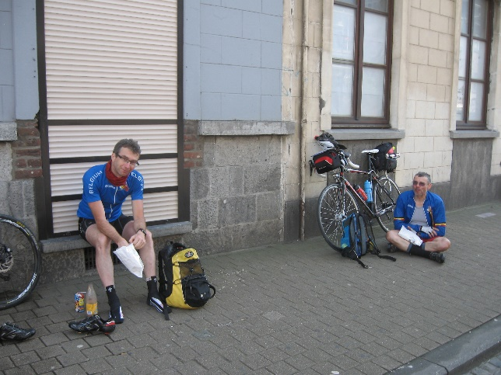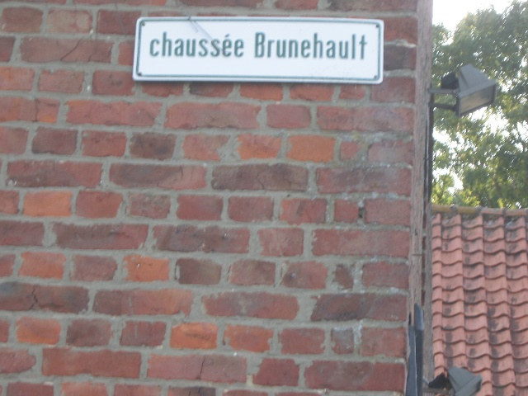
Johan and Patrice brief break in Binche. Roman road along the route.
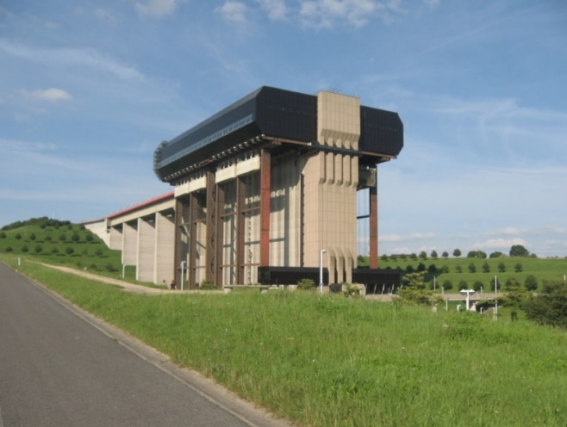 Boat lift at Strépy-Thieu,
As the afternoon progressed temperature began to drop and before long daylight dimmed gently. We’d be finished soon. As we entered the finish, a small neighbourhood café with terrace, cheers went up, congrats exchanged, pictures were taken and the organizers offered us a free beer. After that buns with sliced cheese, meats and other delicacies. These tasted better than awesome. The brew of course added to the enjoyment.
Epilogue
The ride was over. I started on the bicycle in Brussels, I finished on the bicycle in Brussels, yet the ride was incomplete because of what should be called “Wim’s missing link” (with credit due to Darwin). Not sure if there is an evolutionary explanation in this. Some regrets, of course, but not many. Yet immensely satisfied that I was able to make a lot of lemonade out of those tire lemons on the day before and day 1 of the ride and was able to enjoy every drop of it during the brevet. The brevet is highly recommended for a number reasons: its small scale approach with limited entry keeps the event very manageable and personable; the prearranged accommodation with joint breakfast is very appealing; the bag transport allows for minimal luggage en route. The route itself provides variable terrain and attractive landscapes. Combined with the enthusiastic support from Andre and Yvon and you will be in for a very pleasant surprise. Put it on your bucket list. Thanks gentlemen for a great brevet.

* * * * *

